Government Degree College, Pattikonda
Department of Physical Education
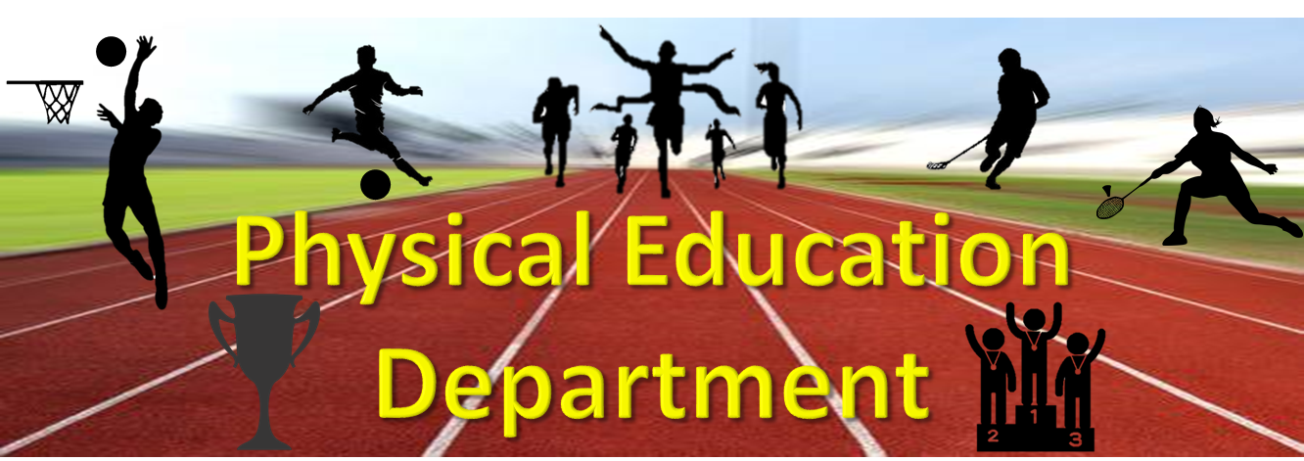
About the Department
The Department of Physical Education of Government Degree College was established in 1988. The Department has dedicated itself to nurture potential in students and mould the youth of college by means of building a strong mind and best physique through right training in physical activities and exposure to develop their skills.
Currently One faculty member is working in the Department;
Sri: TapalShaik.Hussain: M.P. Ed
VISION
- Be the best and lead the rest in the sports education, research and training across the globe.
MISSION
- To promote sports education in the areas of sports sciences, sports technology, sports management and sports coaching besides functioning as the national training center for select sports disciplines by adopting best international practices.
MOTTO
- Sports Excellence through Education and Training.
Aims and Objectives
- The aim and objectives of Department of Physical Education in the College is Wholesome Development of students’ personality and provision of conditions for a complete living and well-being. To participate in activities that are physically fit, mentally stimulating, emotionally controlled and socially sound.
Gallery:
S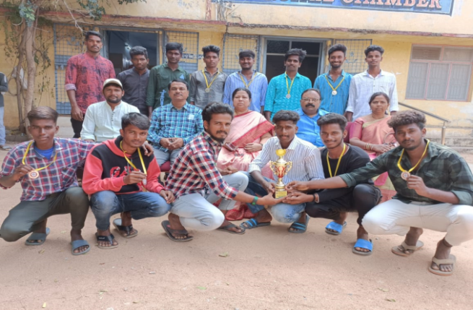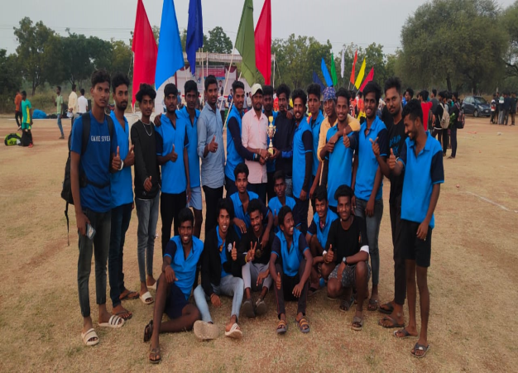

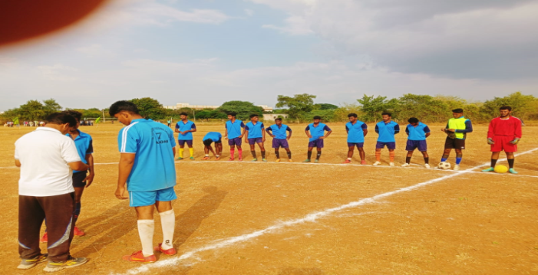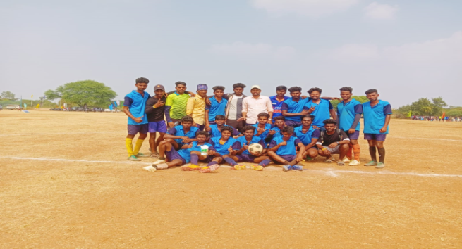

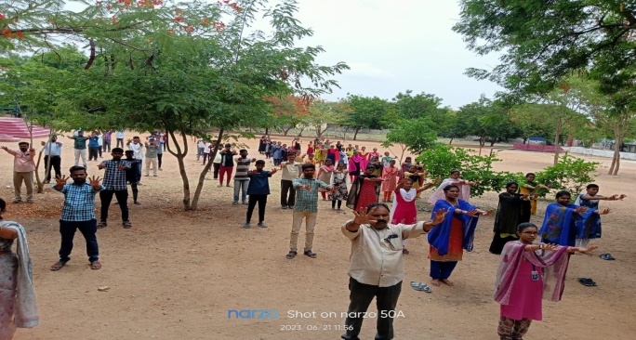
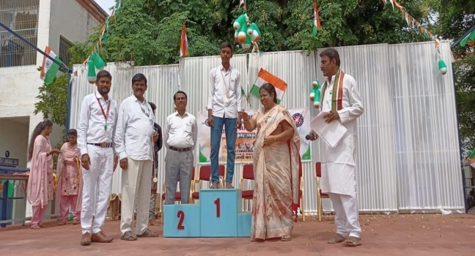
Rayalaseema University Inter Collegiate Tournament our College Won 3rd Place (Cup) 2022-2023
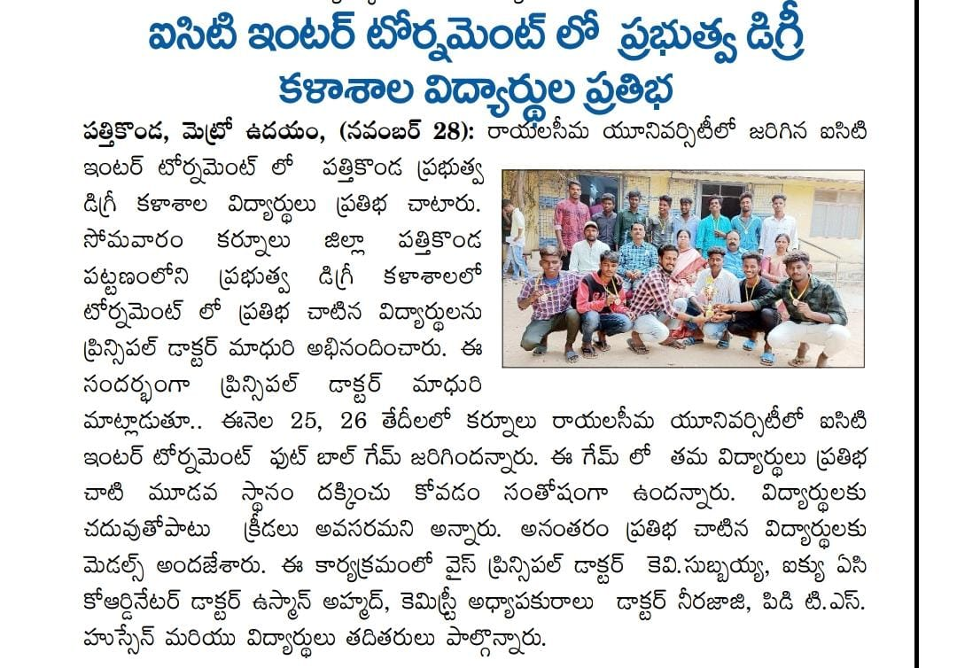

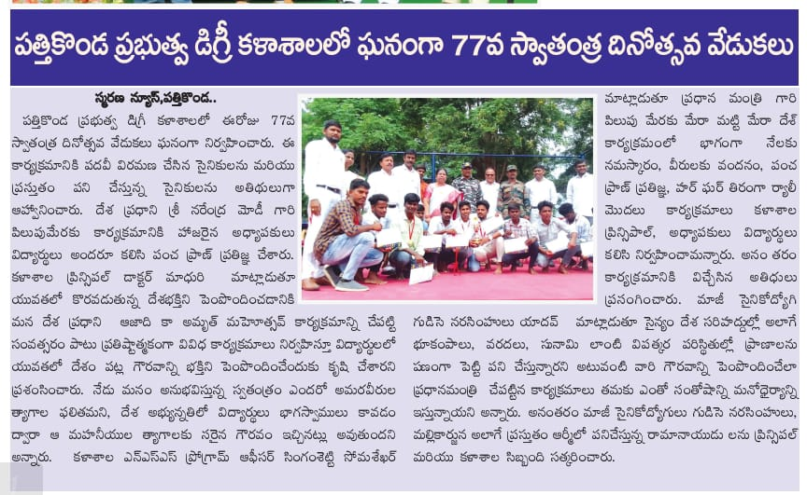
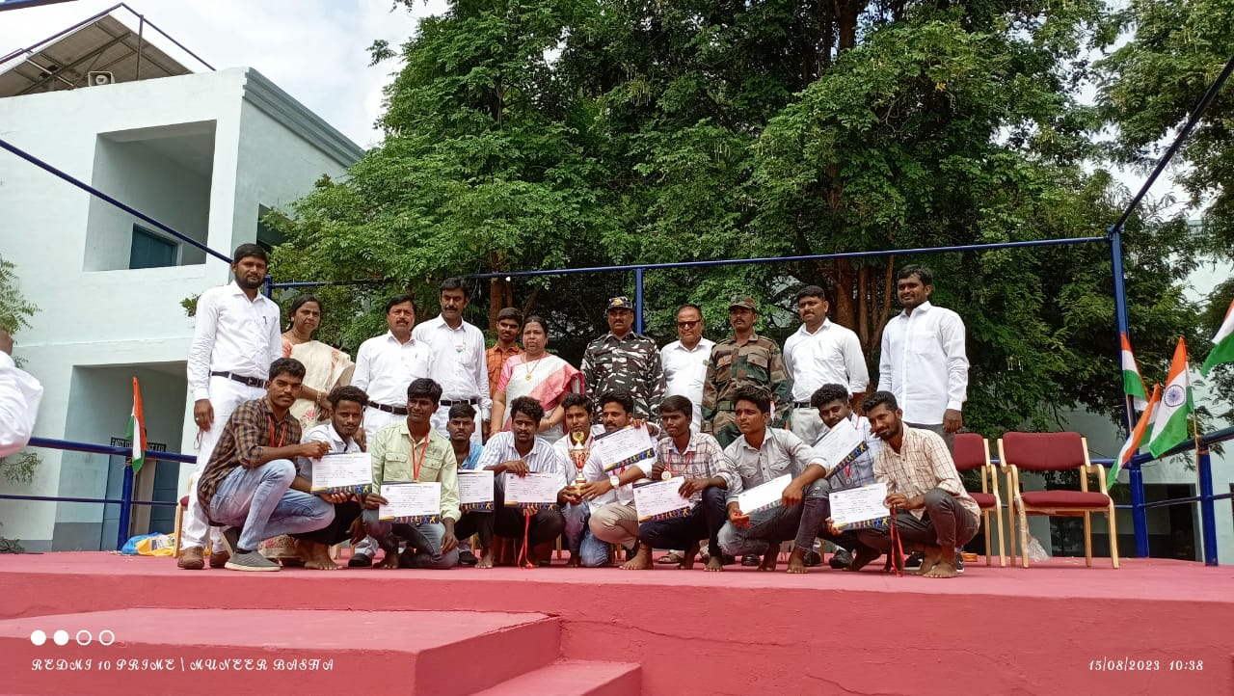

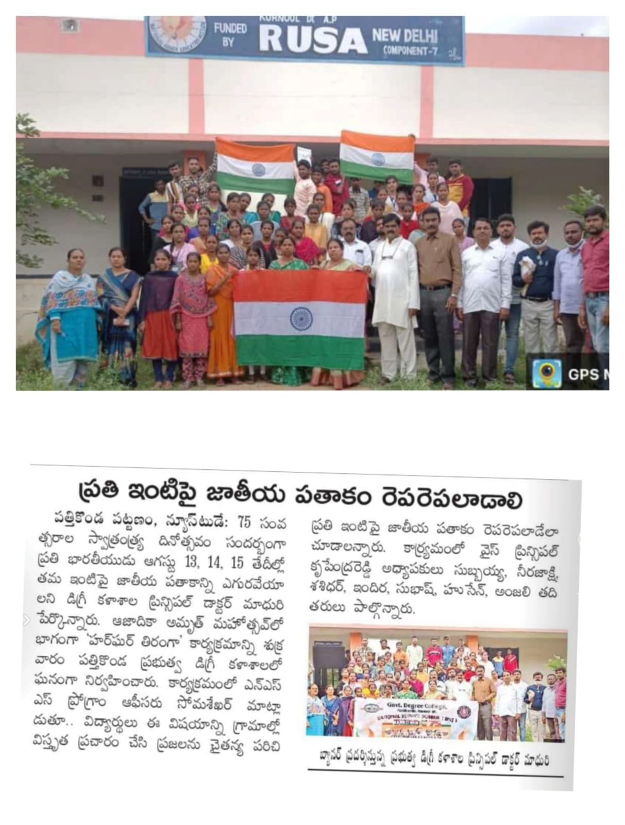

Rayalaseema University Inter Collegiate Tournament (ICT) Our College Students Selected for HOCKY (South Zone Bangalore University)2021-22
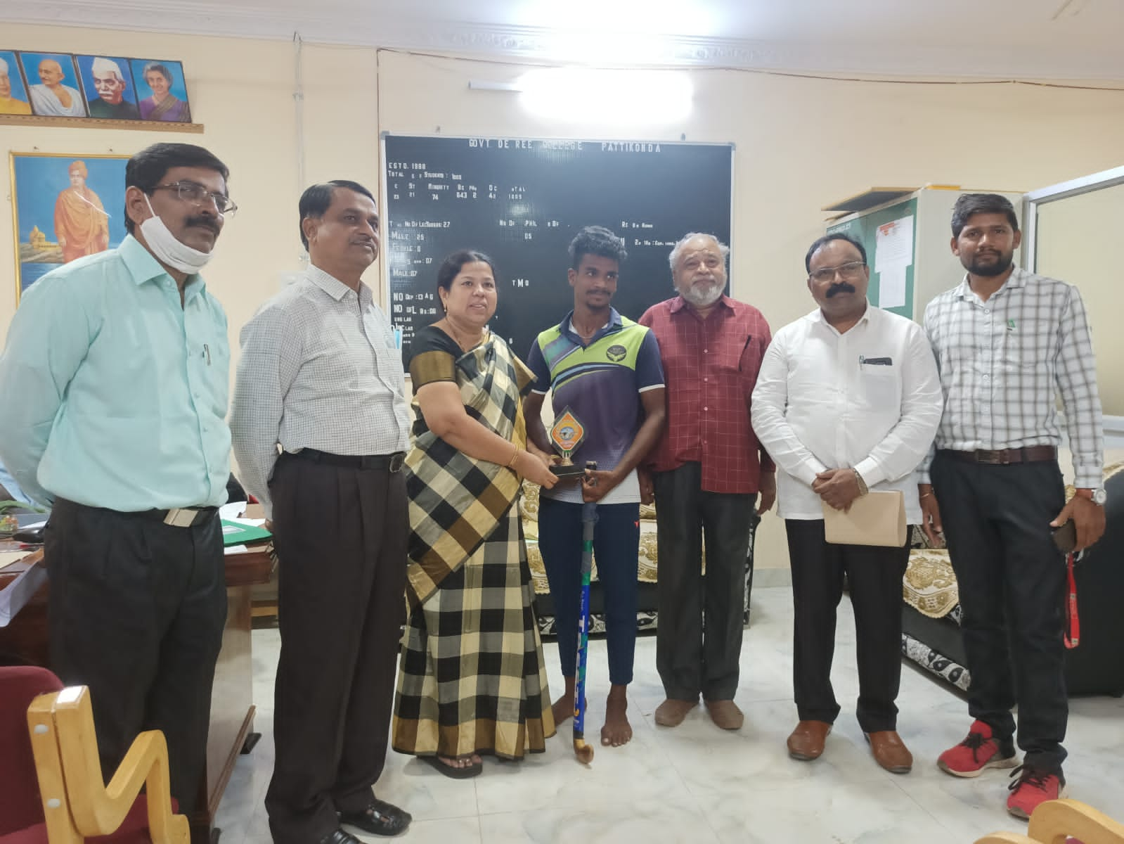s
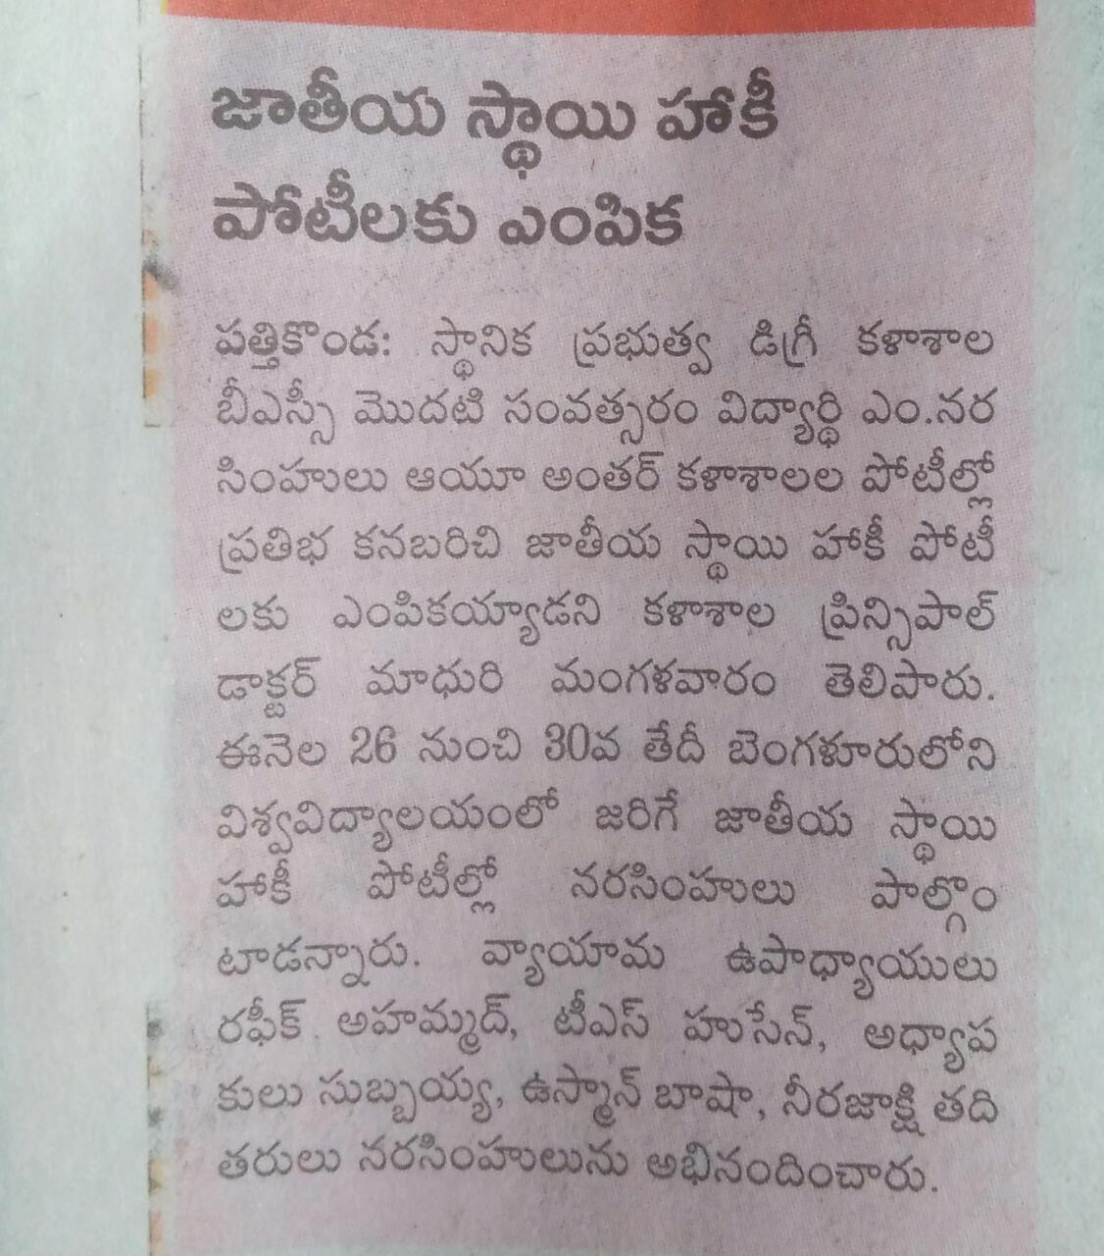
Rayalaseea University Inter Collegiate Tournament (ICT) Our College Students won Bronze medals 2021-2022
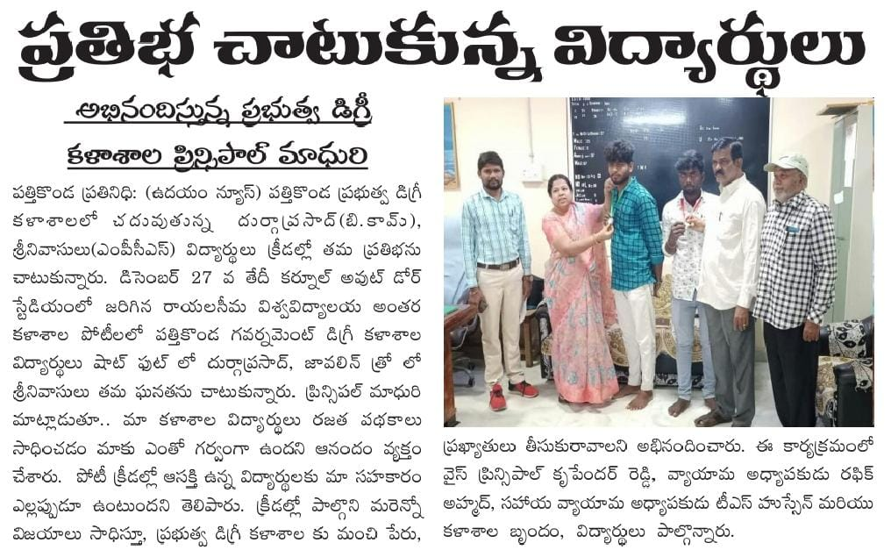

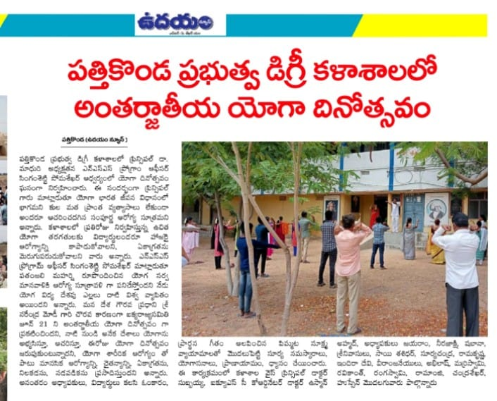
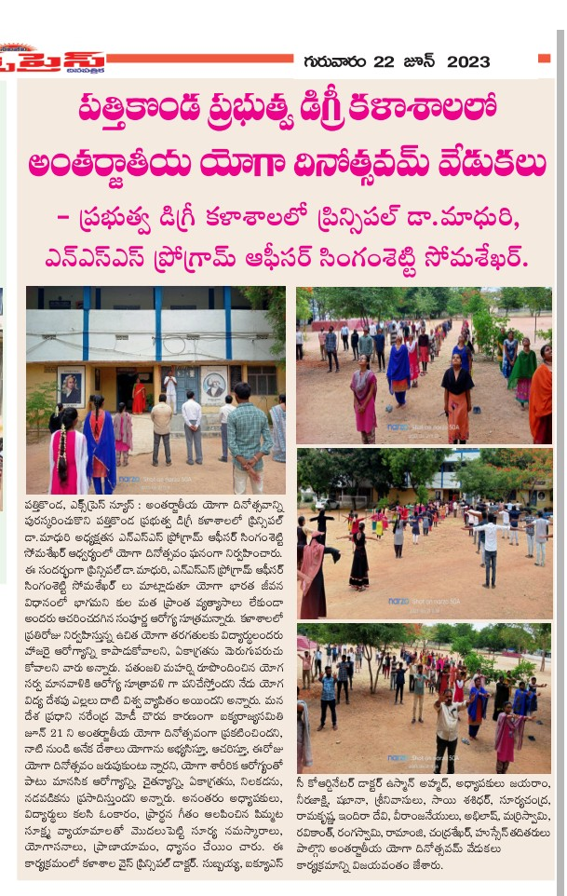
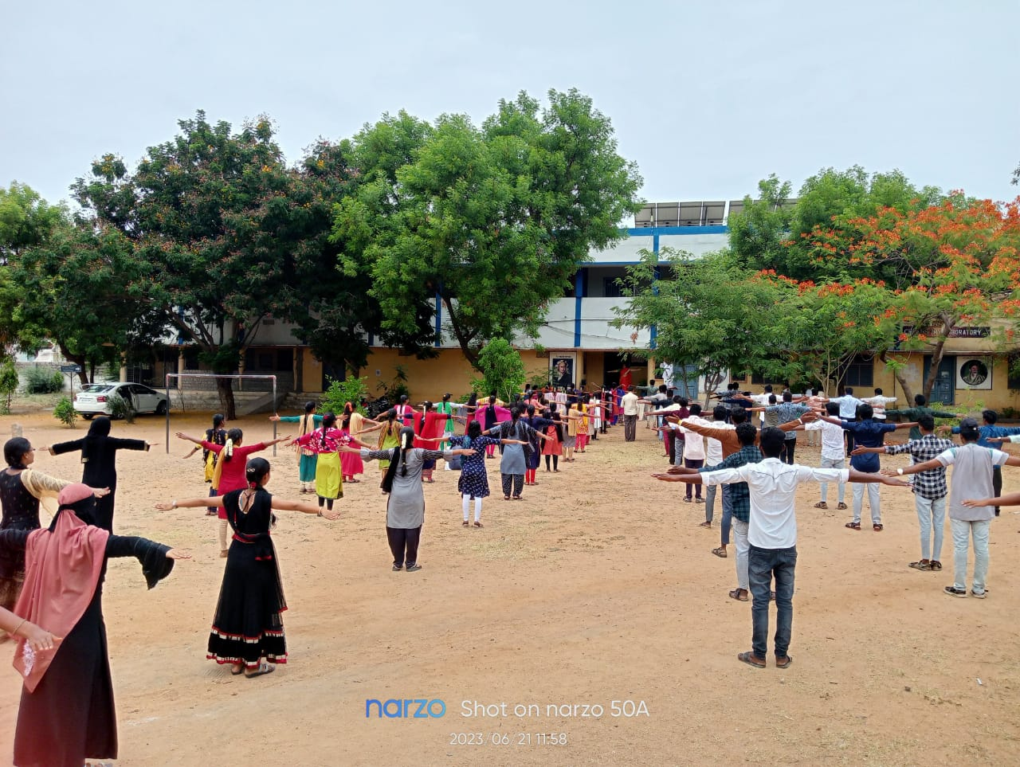
Rayalaseea University Inter Collegiate Tournament (ICT) Our College Student won Selected Kho-kho (South Zone Kakatiya University) 2021-2022
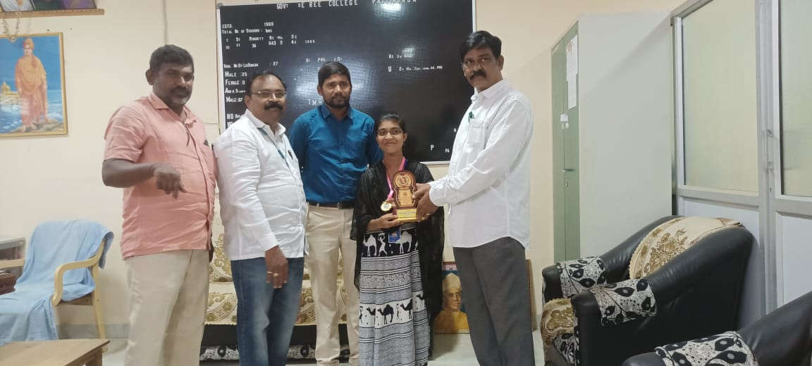

Rayalaseea University Inter Collegiate Tournament (ICT) Our College Student won Selected (FOOTBALL) (South Zone University of Calicut, Calicut ) 2022-2023
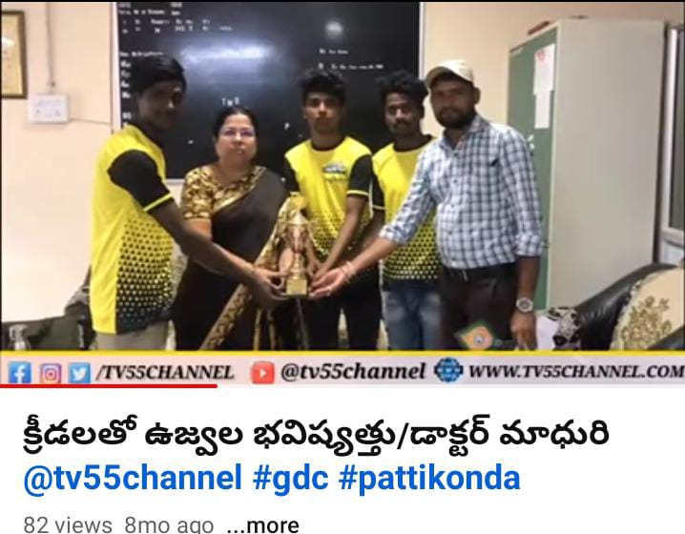
Rayalaseea University Inter Collegiate Tournament (ICT) Our College Student won Selected (CRICKET) (South Zone Reva university,Bangalore) 2022-2023

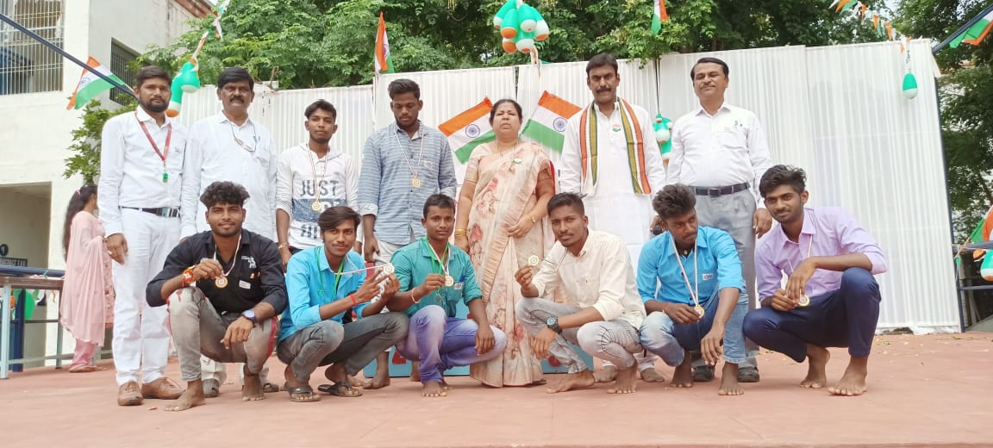

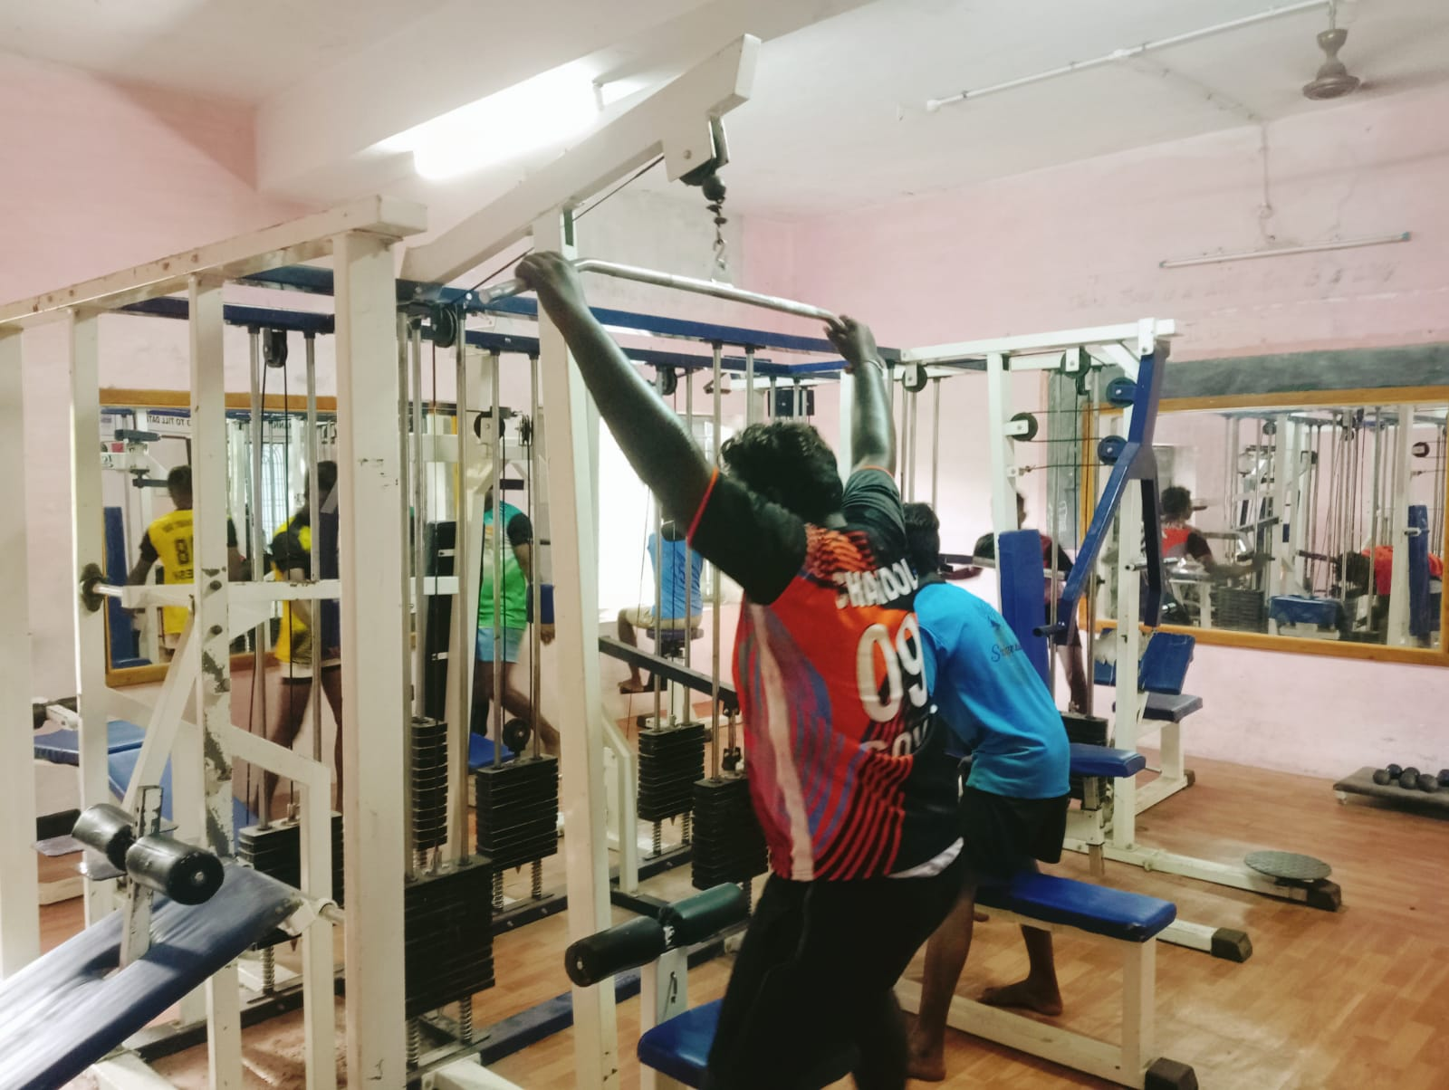
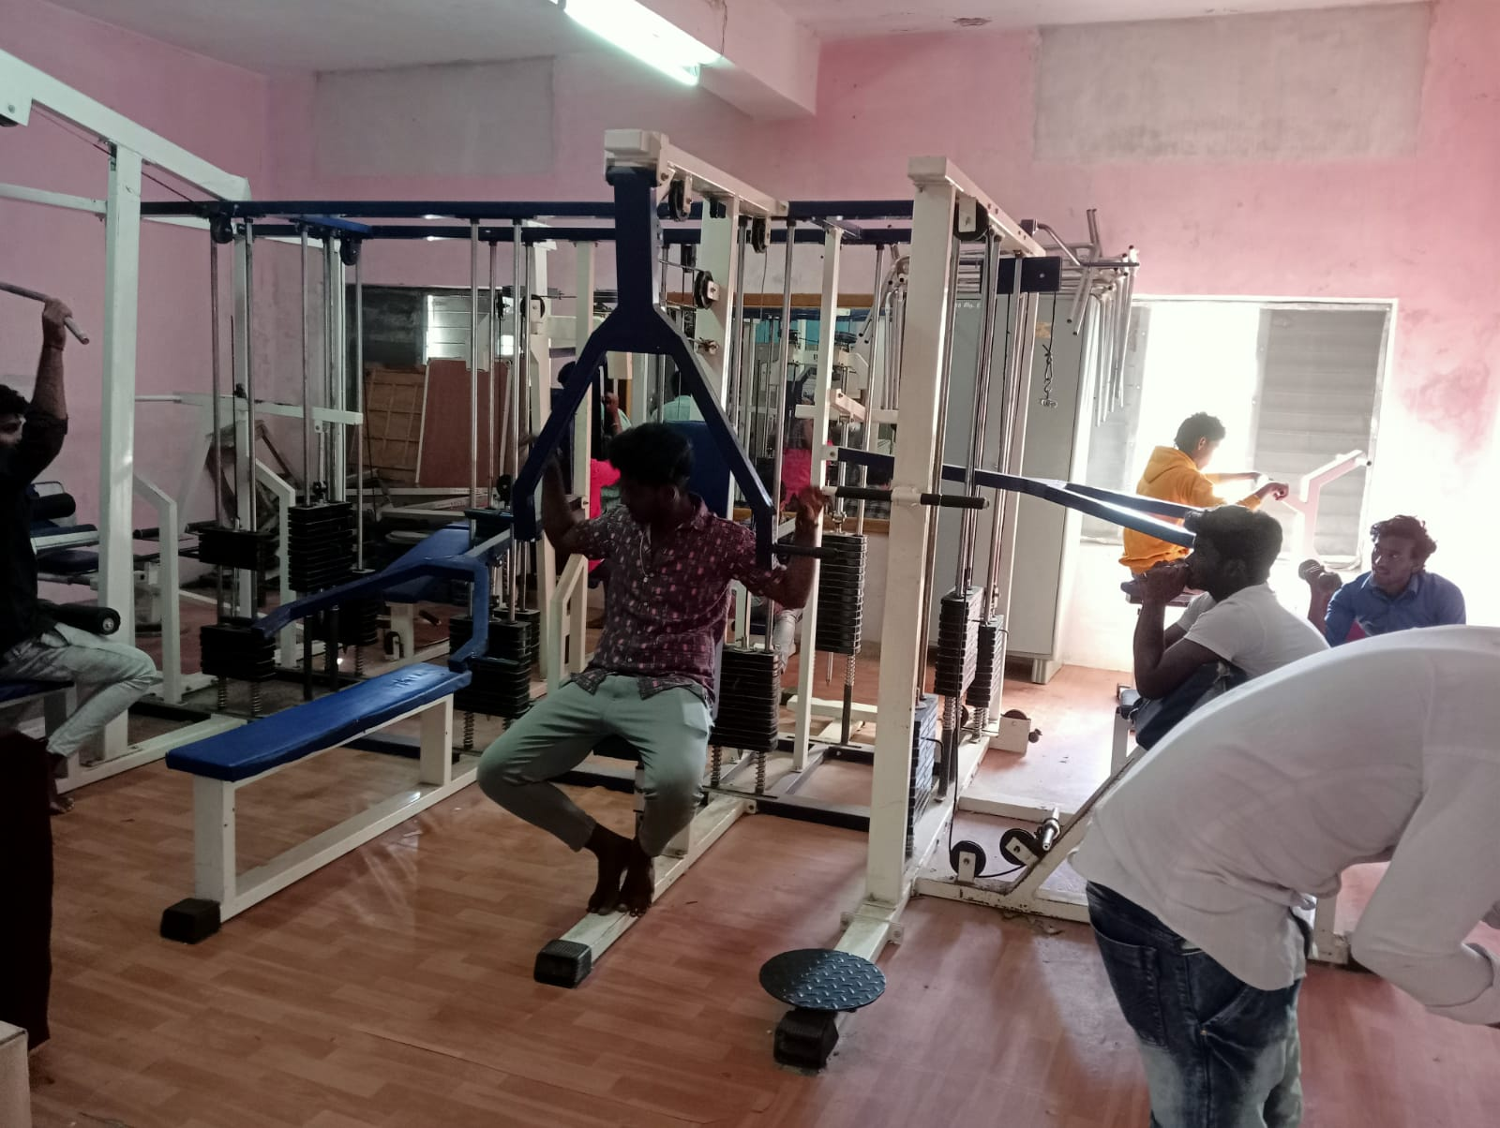
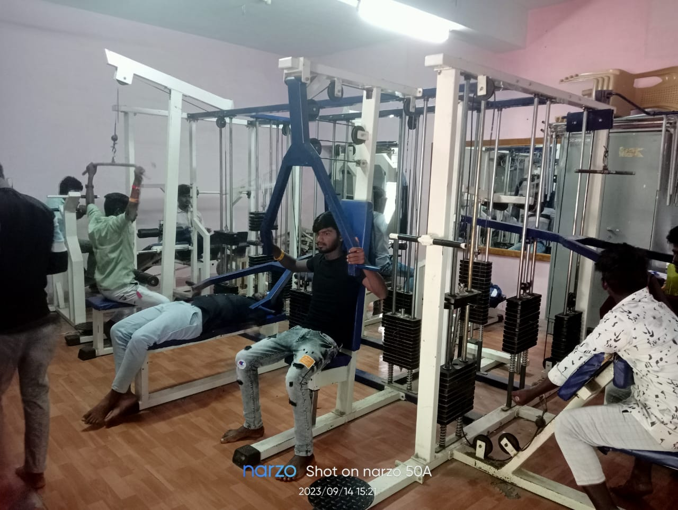
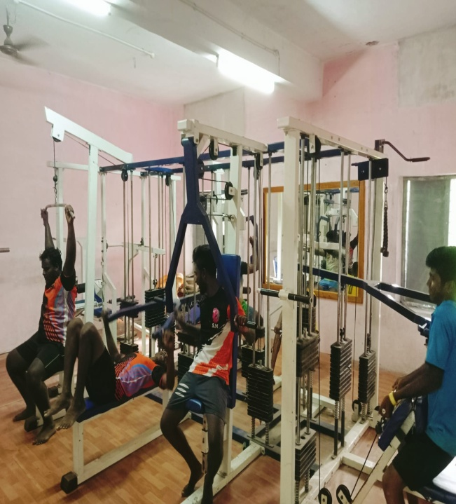

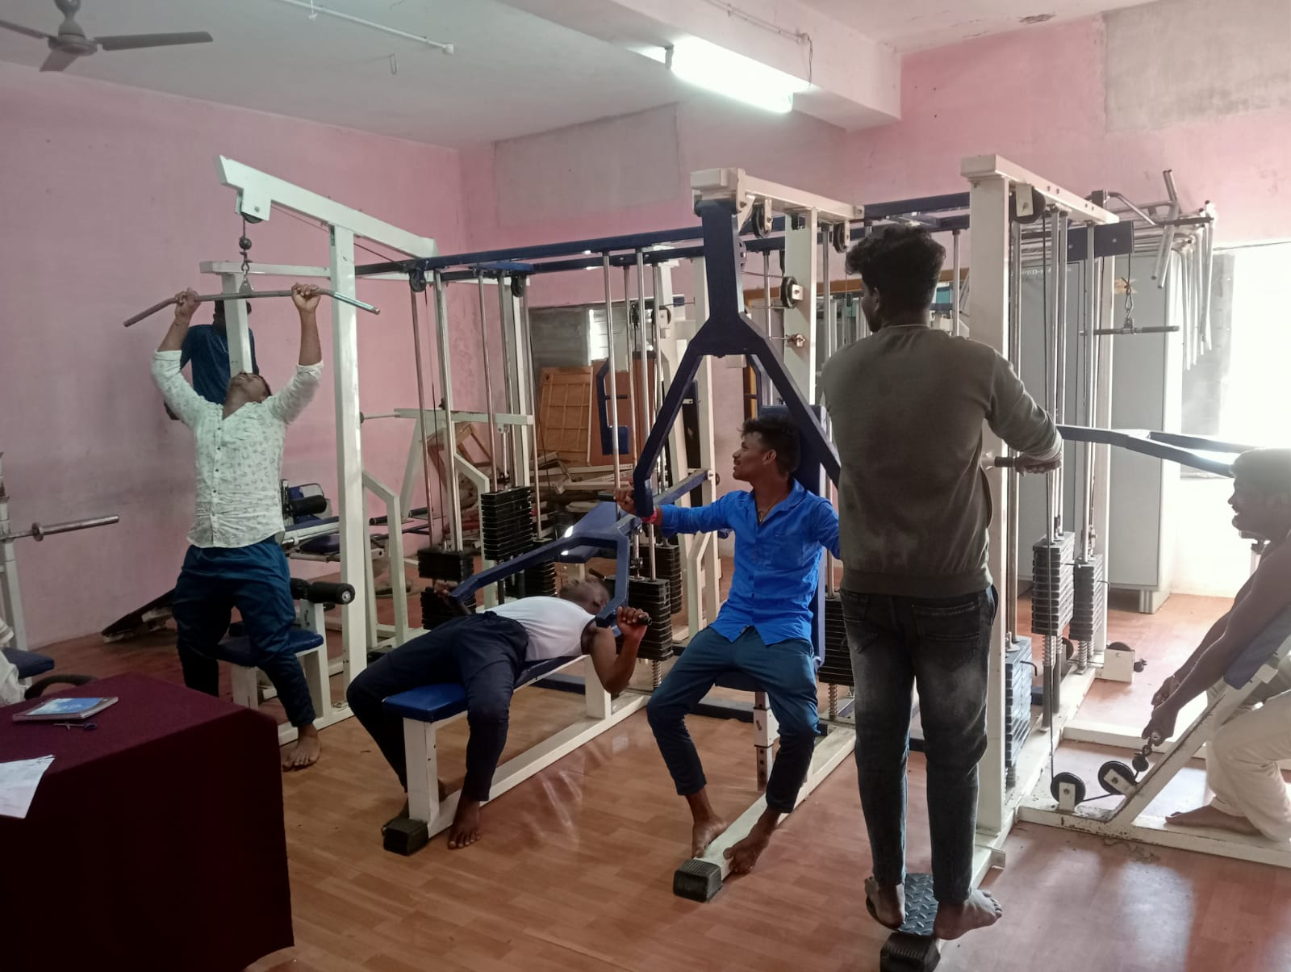

INDOOR GAMES
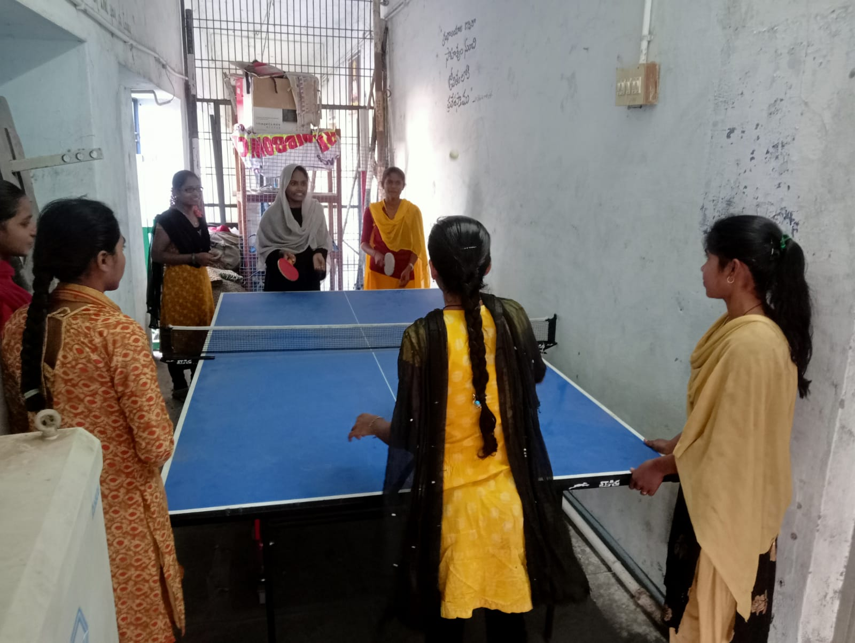
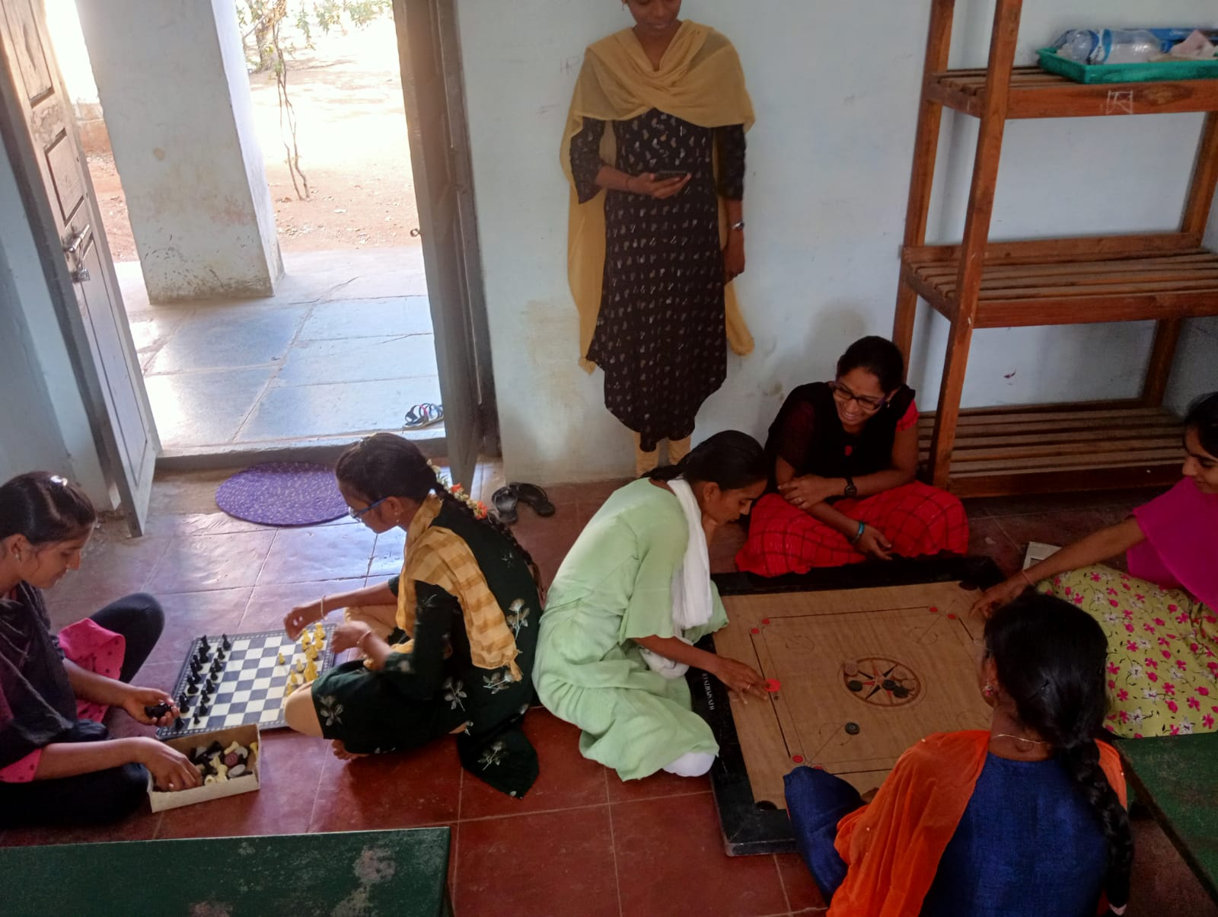
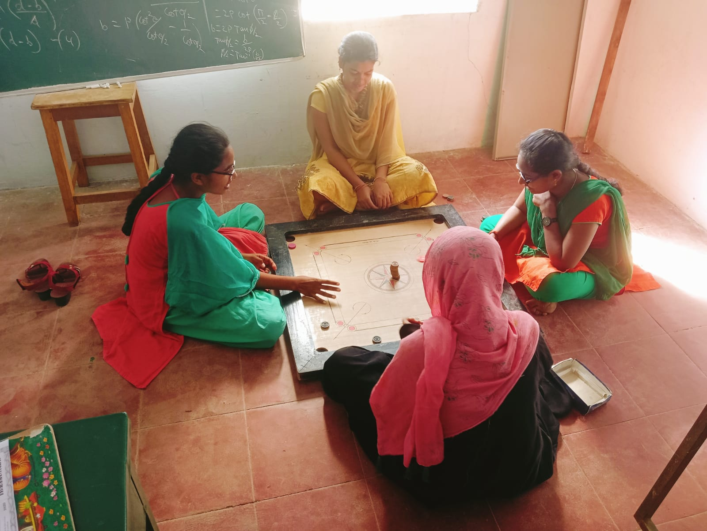

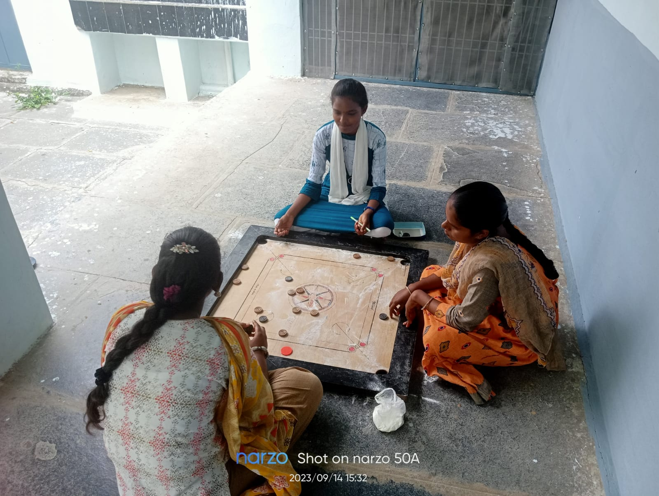

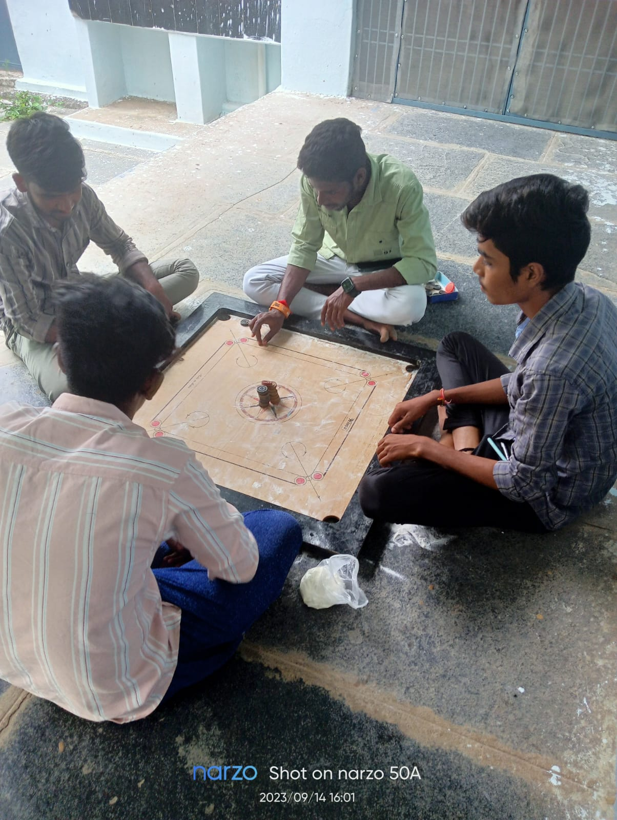
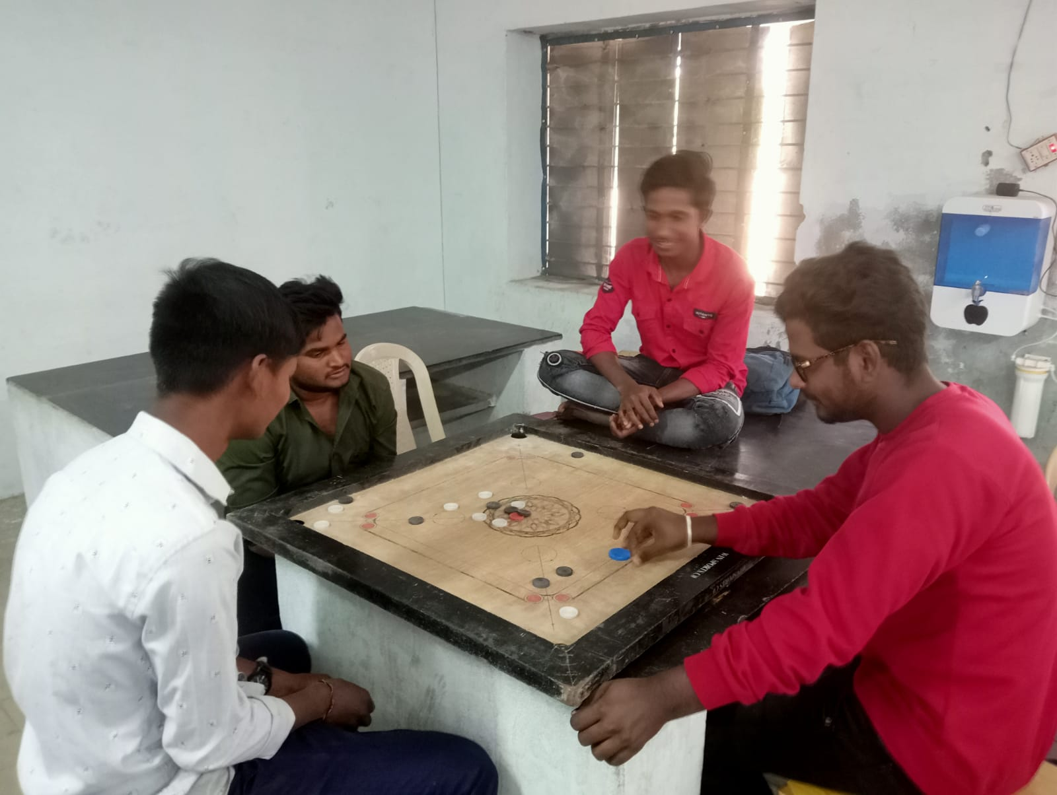
Clean and Green
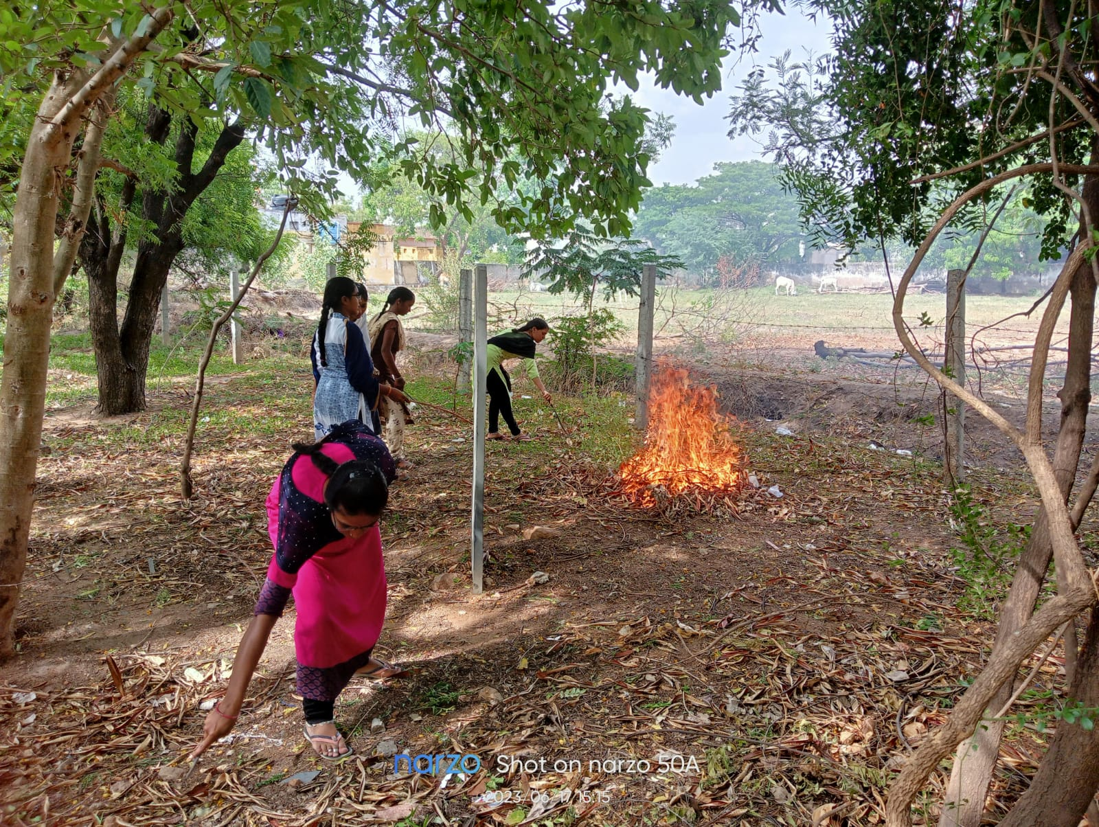

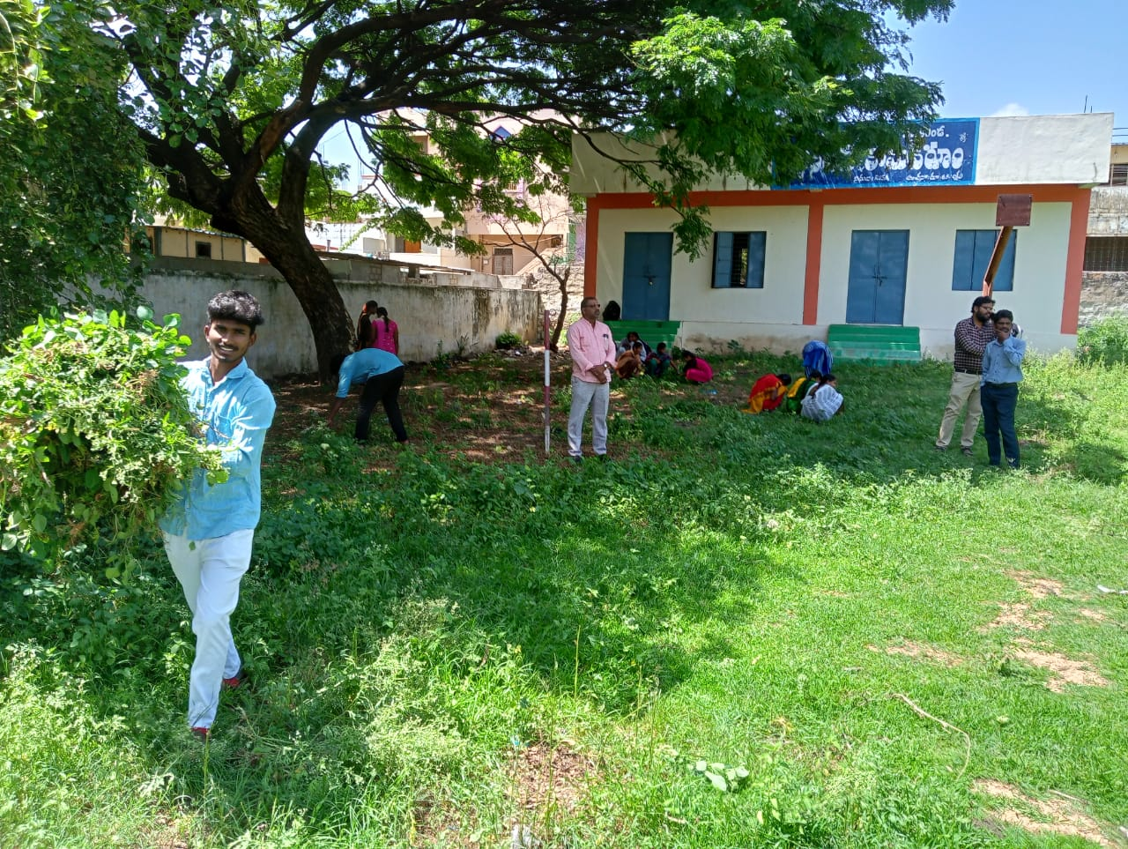
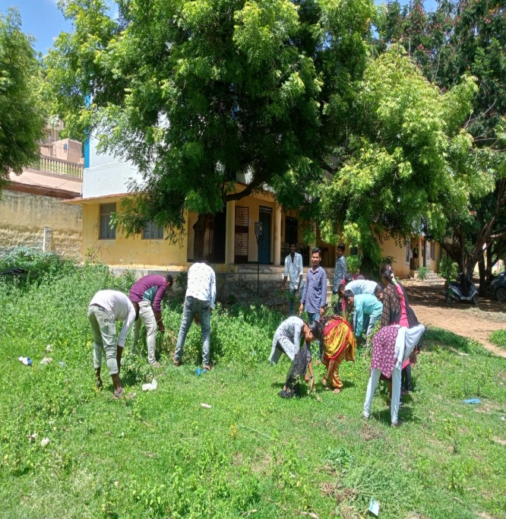
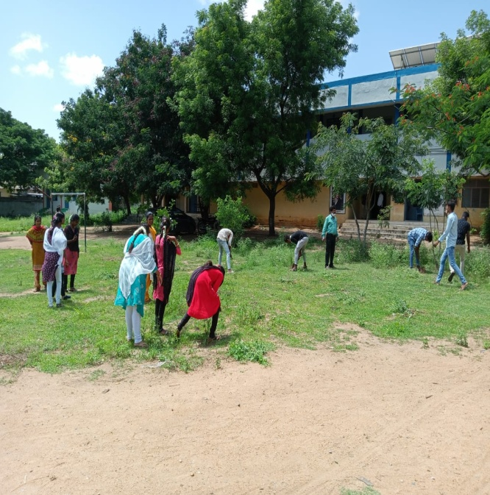
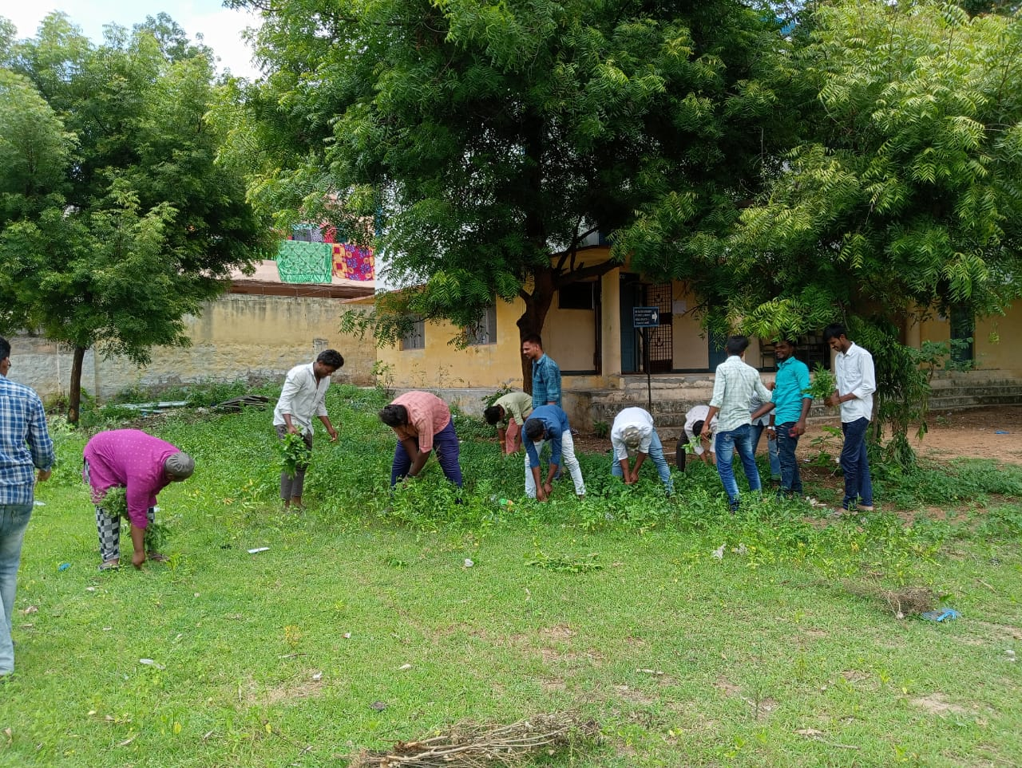

By
Sri.T.S.Hussain
Lecturer-in-Physical Education
Government Degree College, Pattikonda

